**Human Geography - मानव भूगोल**

Tuesday, 6 September 2022

9:35 AM

# Index



# World Human Geography

# Primary activities

* + Activities directly related to natural resources.
    - Related to land - Mines (minerals), soil (Forest, Agriculture)
    - Related to water bodies - Oceans (fishing, other living resources, minerals);  lakes, rivers, etc. (fishing and other living resources).
    - Agriculture -crop growing, animal rearing (animal farms, aquaculture)

## Forestry, Agriculture including Animal rearing in world

**Area of Hunting and Gathering of Forest Produce**

* + Initially before agriculture and civilization, all human beings were living in the forests as hunting-gathering tribes and depended fully on forest resources.
  + Though the use of fire helped these people to spread to different regions of the world.
  + But, they were still forest-dwelling people.
  + Gradually, these people also started collecting food resources from the water bodies and started settling around the fertile grounds around water bodies like lakes. Started creating pre-agricultural hamlets/dwellings. Some very small settlements.
  + Even presently, in some forested, desert, and snow-covered parts of the world, we still find some of the forest-dwelling tribes as by the Eskimos (snow-covered regions of the Asia and North America), Pre-Agricultural tribes in the Amazon basin of South America, Congo basin of Africa, and some parts of Asia e.g. NE parts of India, Andaman & Nicobar Islands and some of the SE Asian countries where the gathering is still practiced.

#### *Beginning of Agriculture*

* + Subsistence agriculture is the agriculture where the main goal is the food supply of farmers and much of the produce is consumed by the farming community/dependent village community. Only the residual produce is sold in the market which is a small share of the produce.
  + This also implies that this kind of agriculture can only mostly support rural societies with the residual additional produce supporting the urban society.
  + This is also the beginning of agriculture, also called - **simple subsistence agriculture**.
  + Simple subsistence agriculture grew with the tribals or forest people who started living on the margins of the forest or by clearing parts of the forest in which they started growing basic food crops using simple methods.
  + This is the oldest agricultural practice by human beings which led to the growth of rural hamlets, small settlements, and villages and hence, the development of some of the first settled human societies.

**Agricultural practices**

* + The agricultural practices involved simple clearing of forests for agricultural land, simple spreading of seeds in the fields, No field preparation like ploughing, tilling, etc.
  + No application of traditional fertilizers or manures.
  + No irrigation, therefore rain-dependent.
  + Very basic food crops grown such as tuber crops rich in energy (potato, yam, tapioca, sweet potato, etc.), basic corns, grains (rice, jowar, bajra, etc.), banana, etc.
  + No crop protection using pesticides, insecticides, weedicides etc.
  + Also, they were changing field locations after a few years as with no fertilizers soil became less productive. This changing of field locations was done by slash and burn of nearby forests. Hence, also known as **slash and burn agriculture** or **shifting agriculture** or **migratory agriculture**.
  + Used very primitive tools.
  + Done by agricultural tribes in the world.
  + Also called **Primitive subsistence Agriculture (**also known as**shifting agriculture)**. It is done in different parts of the world by different names e.g. Central America (Milpa), Brazil (Roca), Africa (Masole), Malaysia (Ladang), India (Jhum and Beware), etc.
  + These agricultural tribes are not producing enough for their food requirement and hence, also partly depend on gathering, fishing, and hunting to fulfil their needs.

**The contribution of simple/primitive subsistence agriculture**

* + It has given us our first settled human societies and supported the agricultural tribes for thousands of years.

#### *Developed/Intensive Subsistence Agriculture*

**Characteristics**

* + Better soil regions such as the more productive river valleys and flood plains with finer soils, having better moisture content e.g. Indus, Ganga, other major rivers of India, Yellow River, Mekong river, Euphrates river, Tigris river, Nile river, Amur Darya (Bactrian civilization), etc.
  + Better soil preparation by tilling and ploughing.
  + Better crop selection in terms of cropping seasons, better quality seeds, better planting methods (like rice sapling planting)
  + Arranged irrigation through channels, wells, etc.
  + Applied traditional fertilizers and manures (farm wastes, crop wastes, domestic waste, animal waste, etc.)
  + Applied traditional pest control methods.
  + Intensive agricultural labour was employed by humans, animals (draught animals)

**Regions - 2 types**

* + Wet tropical Monsoon region - paddy (maincrop) e.g. Japan, China, wet monsoonal regions of India, SE Asia, etc.
  + Dry regions - wheat, soybeans, barley, jowar, bajra, other coarse grains, etc. e.g. northern parts of China, western parts of India, earlier in Indus river basin, drier parts of Burma, parts of West Asia, Amur Darya region, etc.

**Impact**

* + Relatively higher crop production
  + Variety of crops including non-food crops like cotton, silk, spices, jute, etc.
  + Hence, more storage of agricultural outputs.
  + Dependence on forest declined.
  + Farmers became more prosperous
  + Rural community grew
  + Could support more non-agricultural working people.
  + Other economic activities grew such as craft-men, traders, etc.
  + Villages grew, groups of villages grew, gradually leading to the growth of kingdoms, empires, and civilizations.
  + International trade in goods also developed.

#### *Subsistence Animal Cultivation*

* + Equivalent to simple subsistence agriculture in animal rearing.
  + Also known as **Nomadic Herding**
  + Shifting animal rearing - practicing tribes are known as Nomads. These nomads rear herds of animals and hence, this practice is called nomadic herding.
  + They rear different animals in different parts of the world e.g. -
  + In mountains - Snow regions (Yaks), Grass regions (sheep & goats),
  + In grasslands - tropical region (cows, buffaloes), temperate regions (horses)
  + Dry regions - Hot deserts (camels), snow/polar (reindeers)
  + They generally move on traditional routes and they generally live in less populated regions.
  + Names of such nomads - Fulani (West Africa), Masai (East Africa), Bedouin (Saudi Arabia), Tuareg (Sahara), Kyrgyz, Kazakhs, Uzbeks, Tajiks, Turks (Central Asia), Yakuts, Lapps, Eskimos (Polar Eurasia region), Gaddis, Bakarwals, Gurjars (India).

**Contribution**

* + milk giving animals, draught animals, skin, meat, wool, etc. and they sold these to the other settled population.

**Conclusion**

* + Hence, these agricultures discussed above we find that the human beings turned from forest-dwelling hunting-gathering society to agricultural tribal societies doing simple subsistence agriculture, they were semi-settled. Then the intensive subsistence agriculture gradually turned us into larger village communities that could supply food and support non-agricultural parts of rural and urban societies leading to the growth of kingdoms, empires, and civilizations assisted by mining, manufacturing, and trading economic activities. This way, different civilizations grew and the third agriculture - nomadic herding fulfilled the animal produce requirements of such societies.
  + And from the first kingdoms to the growth of European Imperialism mainly driven by international trade we gradually reached the European colonization part of the early modern history of the world.

#### *The Beginning of Commercial Agriculture*

* + The 1600s-1700s - World colonization took place by Europeans.
  + The late 1700s - Industrial revolution happened in Europe.
  + IR led to modern factories in Europe for cotton textile and other industries.
  + For these industries, Europeans needed agricultural raw materials like cotton, rubber, cocoa, etc. for food they needed luxury items like tea, coffee, sugarcane, etc.
  + To grow these, they introduced these crops as the fourth type of agriculture called **Plantation Agriculture**.
    - In India - Tea, Coffee, Rubber
    - S America - coffee, rubber, sugarcane
    - N America - cotton, sugarcane
    - Africa - coffee, rubber, sugarcane
    - SE Asia - rubber, coffee
  + Plantation Agriculture was the beginning of Commercial agriculture in the world.
  + It also included crops like bananas, pineapples.

**Characteristics of Plantation agriculture**

* + It is done on large privately owned estates.
  + This is normally a business purpose for the owner.
  + Local labours as working farmers.
  + All produce is sold.
  + Scientifically done.
  + Good capital investment

**Regions**

* + India, Sri Lanka, many parts of Africa, in S America e.g. Brazil, Central America, SE Asia, etc.
  + It is still being practiced mostly to supply the given crops in different parts of the world on a commercial scale.
  + This agriculture helped the industrial revolution in a big way by supplying the raw material for factories.
  + Hence, gradually as the industrial revolution in Europe grew and industrialization further grew, it required more industrial labours for which the European countries used their local laborers, Europeans only, who got improved salaries and better lifestyle working in the factories.
  + But more industrial labour in factories meant less agricultural labour in their European farms as their own countrymen have shifted from rural areas to urban areas to work in factories. Also, the food crops of these new urban laborers were the same crop they were growing in their farms in Europe, and not the tropical food crops are grown in colonies.
  + Hence, gradually this led to the **commercialization and mechanization of European food crop farming**.
  + It is also called **Extensive commercial/mechanized grain Farming.**
  + This initially grew in the colonizing countries of Europe in 1800-the 1900s and also in their newly created colonies and countries e.g. USA, Australia, New Zealand, etc.

**Characteristics**

* + It is done on very big farms, thousands of acres.
  + Heavy use of machines and very less use of manual labour.
  + In one farm mostly one type of crop will be grown year after year.
  + Crops are grown mostly for commercial selling.
  + Total production is very high per farmer.
  + Very scientifically done agriculture with soil testing, chemical fertilizers, pesticides, etc.
  + Supporting agriculture with irrigation, fertilizers, etc.
  + Productivity (per unit area production) is high but not the highest.

**Regions**

* + North America, parts of Europe (steppes), parts of Argentina, Chile, etc in S America, South Africa and parts of Australia, New Zealand. Now also in China (Manchurian grassland)

**Crops grown -**Wheat, oats, barley rye, maze and the European vegetables (temperate region vegetables), soybeans, etc.

### European food crop farming

**Livestock Ranching (Extensive Commercial/ Mechanised Animal farming)**

* + Developed countries of the world mostly in temperate grasslands.
  + Very large farms called ranches having nearly continuous fodder cover.
  + No migration.
  + Large commercial scale.
  + Few ranchers (owners)
  + Highly mechanized
  + Scientifically managed
  + Advance refrigeration & transportation

**Animals grown**

* + Milk - Cows (temperate variety)
  + Meat - cattle, sheep (also for wool), pigs
  + Horses
  + It is mostly done in open field areas of N America - USA, Canada, Mexico; in S America - Brazil, Argentina, Chile, in South Africa, less populated parts of Europe, and Australia and New Zealand.
  + Processed products of milk are sold.
  + So complete food processing industry grows around it.

#### *Intensive Commercial Mixed Farming*

**Characteristics**

* + Done in some of the most developed agricultural regions in the world which are mostly near the urban regions, Hence also called **Market Gardening**.
  + Fresh produce is more frequently sold from the farm to the market with more frequent transportation, hence also called **truck farming**.
  + This uses the most advanced tech to produce the highest grade of agricultural produce which is sold at a relatively premium cost.
  + Less chemical use, more organic, fresher, and not refrigerated.
  + Generally done on smaller farms.
  + Mostly fruits, vegetables, animal produce, milk produce, etc. are grown.
  + On the same farm, both animals and crops are grown and the waste of one becomes the input of others. (this is similar to small scale agriculture done in developing countries like India - intensive subsistence agriculture - where farmers use fewer chemicals and grow both crops and animals and the waste of one becomes the input to the others but the difference is, in developing countries it is non-scientific, mostly on traditional old knowledge, not using the benefit of new scientific developments.
  + Whereas in commercial mixed farming in addition to the benefits of growing both animals and crops together, they also use the latest scientific developments such as micro-irrigation methods, vermicompost, precision agriculture (sensor-based), scientific soil testing methods.
  + A specialized form of Mixed farming is known as dairy farming where the focus is on dairy but the animal waste on large scale is used for fertilizers in farms.

**Regions -**

* + N America, coastal areas, Brazil & Argentina - coastal and populated areas
  + South Africa
  + Throughout Europe
  + Also near urban areas of S Korea, China, and Japan.
  + Australia, New Zealand
  + Dairy farming is also done in similar areas.

#### *Mediterranean Agriculture*

* + This is also commercial agriculture done in Mediterranean-type climatic regions of the world.

**Regions**

* + Mediterranean region of Europe
  + California region of USA
  + Central Chile region (S America)
  + The western coastal part of country S Africa.
  + Southern coastal Australia
  + Northern New Zealand

**Produce grown**

* + Citrous fruits, berries including grapes, olives.
  + These are processed and then sold. E.g. grape processed into wine.
  + Hence all Mediterranean climates of the world are wine-producing areas of the world.

* + agriculture 
    apiculture 
    aquaculture 
    arboriculture 
    aviculture 
    floriculture 
    horticulture 
    mariculture 
    monoculture 
    permaculture 
    sericulture 
    silviculture 
    vermiculture 
    viticulture 
    farming 
    bee-keeping 
    aquatic animals or plants 
    ornamental trees 
    birds 
    flowers 
    gardening 
    sea fish or other marine life 
    cultivation of only one sort of crop 
    development of sustainable agriculture 
    silk and silkworms 
    earthworms 
    grapevines 
    ager, field 
    apis, bee 
    aqua, water 
    arbor, tree 
    avis, bird 
    flos, flower 
    hortus, garden 
    mare, sea 
    Greek mono, alone or 
    single 
    a blend of permanent 
    and agriculture 
    sericum, silk 
    Silva, wood 
    vermis, worm 
    vitis, vine 

## Forest Resources

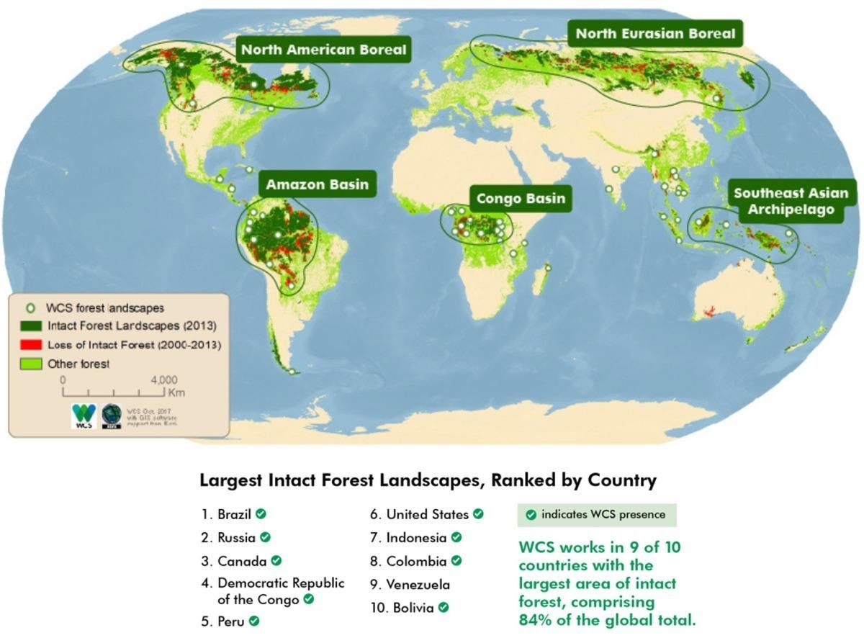

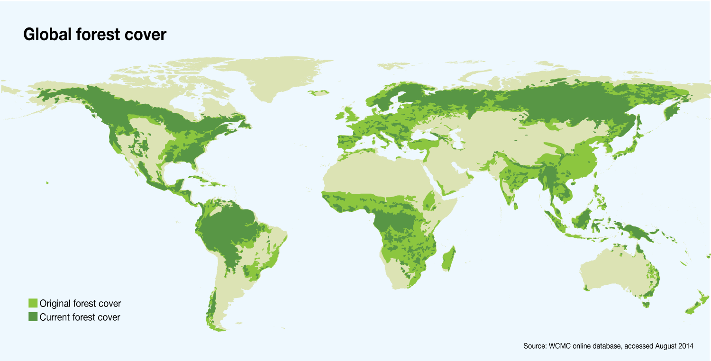

## Mineral Resources

* + Resource - anything of which we realize and understand the useability (in economic terms), becomes a resource. It is an economic term in general.
  + Material Resources -
    - Biotic like forest etc.
    - Abiotic - two types -
      * Renewable - solar, wind, tide,
      * Mineral - Gas (natural gas, petroleum gas, etc.)
    - Liquid - crude oil, petroleum products
    - Solid - rocks, ores (rich in required elements)

**Metallic minerals -**

* + Ferrous - Iron, Mn Ni, Cr (Non-electrical use)
  + Non-ferrous - Cu, Al, Tin, Cad, Zinc (Electrical use)
  + Precious metals - Gold, Silver, Platinum, etc. (electronic industry)
  + Lanthanides (rare earth metals) - High-end technology e.g. Missile tech, Modern electronics, magnetism, etc.
  + Actinides - radioactive elements like Uranium, Thorium, etc.

**Non-metals**

* + Chemical industry-related - phosphates, sulphates, etc.
  + Construction Industry - limestone (cement, fertilizers)
  + Energy minerals - gas, liquid, and solid fossil fuels
  + The non-metallic energy minerals are called fossil fuels because they are mostly formed by the fossil deposits of plants and animals. Mostly when the fossils get deposited in the rifts, continental shelves, faults, depressions during the convergence or divergence of plates.
  + Over the period, their fossils get sedimented, and chemically the organic carbon concentration increases which have high calorific value (simply said they can give high heat energy by burning)

**World Mineral Distribution**

* + Shown with handout maps.

#### *Energy Resources*

**Major Coal deposits of the world**

Suß 
PERT 
DIFFERENT LAYERS OF COAL 

* + Type of coals - lignite, bituminous, anthracite.
  + All the fossilified fuels in the world were sedimented during **Carboniferous Period**.
  + Out of all fossil fuel deposits, coal deposits are most distributed.

**Coal deposit in India**

* + Coal deposits are found mostly in the Gondwana region which is a Bituminous type.
  + Some Lignite deposits are also found.
  + Anthracite coal is found only in the Ladakh region in a small amount (costly transportation though).
  + Most of the Bituminous coal is found in three major river valleys -
    - Damodar River Valley
    - Son-Mahanadi River Valley
    - Godavari River Valley
  + Whereas the Lignite coal is found in Tamil Nadu (Neyveli region), some of the North-Eastern states, and some regions in Rajasthan Gujarat.

**Crude Oil Reserves**

* + From the refining crude oil, we get naphtha, diesel oil, fuel oil, aviation turbine fuel, adhesive base, synthetic fibre base, fertilizer base, many chemical solvents i.e. paints, plastic, rubber, cosmetics, etc.
  + All these raw materials from refining are called Petro-chemical, used in petrochemicals industries.

**Distribution in world**

* + The Middle East holds 65% of the world’s deposits.
  + Other regions - N America, S America, Africa, Asia, etc.
  + Explained with the help of the handout.
  + Distribution in India
  + Reserve - Western Offshore > Assam > Gujarat > Eastern offshore > Rajasthan etc.
  + Source to refer - India Yearbook 2022 - chapter on Industry (section - Mines & Minerals).

**Natural Gas Reserves**

* + Explained with the help of diagram in the handout - both world and India.
  + Another type of natural gas is **shale gas** which we get from crude oil shale regions.
  + **Coal bed methane** is another type of natural gas which we get from coal deposit regions.
  + **Methane hydrates**are also another type found along the continental shelf region.

**Uranium Reserves**

**Thorium Deposits**

* + Jharkhand, Odisha, Andhra Pradesh, Kerala.

# Secondary/ Manufacturing Sector in the world

* + Processing and value addition of primary resources to manufacture newer goods.
  + **Factors** affecting the location of manufacturing industries -
    - Geographically we have to look into major factors that affect the location of different manufacturing industries in the world. This major factors are listed below -
      * Government policy e.g. capitalist (welfare capitalist, laissez-faire), socialist (mixed), and communist policies
      * Human Resource - when the govt provides social infrastructure such as health, education, employability skills then the population turns into human resources.

* + **Three types of human resource -**
  + Unskilled labour (involved in the primary activity)
  + Semi-skilled labour - for simple manufacturing
  + Highly skilled labour e.g. Japan for producing high-tech products.
  + Managerial workforce e.g. Singapore.

### Factors affecting the location of industry

* + **Raw materials**
  + If the raw material is local then industries might be located near the raw material region for reducing the transport cost of raw material.
  + But if the raw material is imported then industries might be located on the ports for easily importing, manufacturing, and sending.

* + **Capital**
  + If local capital is there then manufacturing industries are located within the country.
  + And most of the profits also remain in the country.
  + Whereas if the capital is a foreign investment then manufacturing will be located where the foreign investment gets a maximum return and maximum savings.
  + Hence such manufacturing must shift over a period of time on the basis of savings and return.
  + **Market**
  + If the production is done for the local market then manufacturing is done close to the market.
  + Whereas if manufacturing is done for global markets then the manufacturing location is generally closer to ports for reducing transport cost or closer to cheap labour locations.
  + **Transport**
  + Industries might be located on the basis of the mode of transport available.
  + In the most industrialized countries of the world, water transport is both coastal and inland as well as railway transport.
  + Among all the modes of transport water-based transport is the cheapest mode of transport and it can be both coastal and inland.
  + Costal transport can be domestic or international.
  + On land railway commercial is the cheapest freight services.
  + Road transport in commercial terms comes 3rd.
  + Air transport is the costliest mode of transport.
  + **Other factors like historical, climatic, geographical.**
  + Historical factors - e.g. gems and jewellery industry in Surat.
  + Climatic- Milk processing industry in Denmark.

### Major Economic regions in the world

* + Asia -Pacific which includes China, East Asian countries e.g. Japan, Australia, New Zealand accounts for 33% of economic activity
  + North America accounts for 22% of economic activity.
  + Western and Central Europe accounts for nearly 18% of economic activity.
  + Indian subcontinent accounts for 7.3 %
  + South America and Central America =6.3%
  + Middle east= 5.3%
  + Eastern Europe =4%
  + Africa =4%

#### *Megaregions of the world in terms of output and GDP*

* + Washington DC- New York-Boston = 6.3Trilllion $
  + Paris- Amsterdam-Brussels- Munich = 2.5 Trillion $
  + Chicago-Detroit-Cleveland -Pittsburgh (great lake region ) = 2.1 Trillion $
  + Tokyo industrial region = 1.8 Trillion $
  + San Francisco-Los Angeles region
  + Seoul-Busan region.
  + Beijing Shanghai region.
  + Cairo -Tel Aviv region.
  + Sau-Paulo region.
  + New Delhi- Lahore region.

#### *Major industrialization in the World*

* + 1770s= industrial revolution 1.0 driven by steam power benefitted the colonizers(western European countries)
    - European colonies in the new world e.g. America and Canada
  + 1870's =  2nd industrial revolution driven by electrical energy and petroleum driven engines. Benefitted Europe and the USA.
  + 1910s = 2nd industrial revolution also benefitted Soviet Russia.
  + 1960 s= 3rd IR driven by electronic and computers benefitted, USA, Western Europe, Eastern Europe, Countries of Asia (Japan, South Korea ) and Singapore, Taiwan, Hongkong.
  + 1970s= developed post-Mao China.
  + 2000's = 4th IR driven by AI, Robotics, Internet.

**Britain**

* + The British industrialization started with 1st industrial revolution driven by local and colonial raw material, local labour, local technology and capital, sea transport, developed railways serving the global market.
  + They developed capital, intermediate, and consumer goods.
  + Major industrial regions of England = Midland region, England region, Yorkshire region, Manchester region, greater London, Scotland, South Wales region.
  + Considered as 2nd most industrialized country of Europe.

**Germany**

* + First is Germany which was a pioneer in scientific and industrial research.
  + They had the mineral-rich region e.g. Ruhr region, had well-developed transport region, inland water transport, interlinking of canals , and hence transport efficiency is high.
  + Also after the unification of Germany in 1989 after the fall of the berlin wall, the overall German industrialization has increased.
  + They are among the world leaders in the industry.
  + Major industrial region = Ruhr region, Middle Rhine region, West German industrial regions, East German industrial region.

**France**

* + Is the third most industrialized country in Europe.
  + Much less resource-rich country of Europe depends on import.
  + French industries are not that well known globally.
  + Major region- north-eastern industrial region, Lorraine region, greater Paris industrial region and other industrial region.

**Italy**

* + resource-poor region but high in human resources.
  + Also due to the mountainous region, it has good hydroelectric power, good port locations, and proximity to Africa through Mediterranean from where they can import minerals.
  + Most industrialized region - Po river valley region has around 25% of countries area, 50% population, and 75% industries.
  + Other regions include- Denmark, Switzerland, Belgium, Netherlands etc

**North American industrialization**

* + The USA is much more industrialized compared to Canada.
  + Factors for industrialization -
    - Were European colonies
    - Skilled European human resources
    - Less-skilled human resources due to the slave trade.
    - European capital.
    - Raw material-rich region.
    - Hydroelectric, fossil fuel, and nuclear energy.
    - Transport e.g. railways, waterways, roads, ports.
    - Markets of Europe and local markets.
    - Major industrial regions = Great lakes region.
    - New England states.
    - Middle Atlantic region,(connected cities without rural areas in between are called megalopolis).
    - Pittsburgh, Lake Erie region(rich in coal and iron and steel industry ).
    - Detroit industrial region (automobile rich region).
    - Southern industrial region(rich in agriculture, coal, natural gas ).
    - West coast industrial region /Pacific coast region- includes California industrial region- food processing industry due to Mediterranean climate, entertainment industry, the software industry.
    - The north-western region near Seattle - The aircraft industry, aluminium processing requires a lot of energy as this region has a lot of hydroelectric power plants due to the Rockies.
    - Vancouver - fishing industry.

**East European industrialization - USSR**

* + Factors-Capital
  + Technology e.g. defence, space, capital goods.
  + Raw material
  + Communist markets
  + Human resource
  + Characteristics - major producers of capital goods, and moderate in intermediate goods, transition to the consumer-based capital economy was difficult later.
  + Russia is an economy in transition.
  + Industrial regions- Moscow, Saint Petersburg, Ural mountains.

**Asian industrialization**

**Japanese industrialization**

* + First Asian country to become a developed country.
  + Factors -Homogeneity of population because of which human resource development was easy.
  + Mineral poor, Capital poor but high aspiration for their country.
  + Have a high savings rate resulting in the development of capital.
  + Focused on export, market access.
  + Integration with the global economy using Mc Arthur Plan.
  + They got foreign capital, imported raw materials, foreign market, technology.
  + they have natural harbours and hence ports.
  + Also, have a good railway network.
  + Automobile industry.
  + Hydroelectric power due to mountainous location.
  + nuclear energy use
  + Indian ocean trade routes
  + Technology-driven industrialization
  + Major industrialist region= Kanto plains 30% industrial output
  + Kinki industrial plain
  + Nagoya region
  + Northern Kyushu
  + South Korea, Singapore, Taiwan, Indonesia, Malaysia, Thailand, Philippines have developed on the same lines.

**China - Industrial Revolution**

* + **Mao Phase (till 1976)**
  + It had traditional closed communist economy. Which means, complete ownership of manufacturing, no private participation, no international trade or relevance except for necessary goods and hence less employment opportunities, very less manufacturing of consumer goods and hence less foreign income.

* + **2nd Phase - Since 1976, till now**
  + After the end of Mao's era, China used its new policy of socialism with Chinese characteristics where they opened up their economy, invited foreign capital in manufacturing sector and used it to train human resource and to skill manpower by investing in social infrastructure and also in physical infrastructure providing manufacturing infrastructure.
  + It also utilized its huge mineral resource base.
  + It also has good power and energy resource base.
  + It is also on international transport route of Asia Pacific and India Ocean from which Japan, Korea etc. had also benefitted.
  + Because of opening of economy, it got access to international markets.
  + It used its strong communist governments to greatly control the labour force, resources, capital investment, currency etc. and hence, this worked as a state run capitalism.
  + Gradually, they are now also promoting their companies which are competing in international market.

**Major Chinese manufacturing bases**

* + Most of the Chinese manufacturing locations are along the coastal regions of China such as -
  + Manchuria, Wuhan, Szechwan, Si Kiang, Lower Chang Jiang (Yangtze Kiang), Shanxi, Tianjin-Beijing.
  + Countries like Australia and New Zealand also followed the Western European and American model of industrialization and have industrialized similarly.
  + Whereas countries like Brazil, Mexico, Argentina, Chile have followed a mixed model of LPG and are at different levels of process of industrialization.
  + Africa as a continent has a huge population but not still turned into human resource due to lack of social infrastructure, weak governments with not much focus on industrialization, huge mineral resource (but it has turned into resource curse as non-developmental governments or rebels are  mostly exploiting the resources by selling legally/illegally to fund themselves). Africa also has good coastal connectivity, access to both Atlantic and Indian Ocean, but the ports are not developed. Hence, Africa has huge potential in future.

* + services example
    - One such example in India is Mumbai's 
      aabbawala (Tiffin) service provided to about 
      1 , 75,000 customers all over the city. 
      Fig. 7.4: DabbawaZa Service in Mumbai 